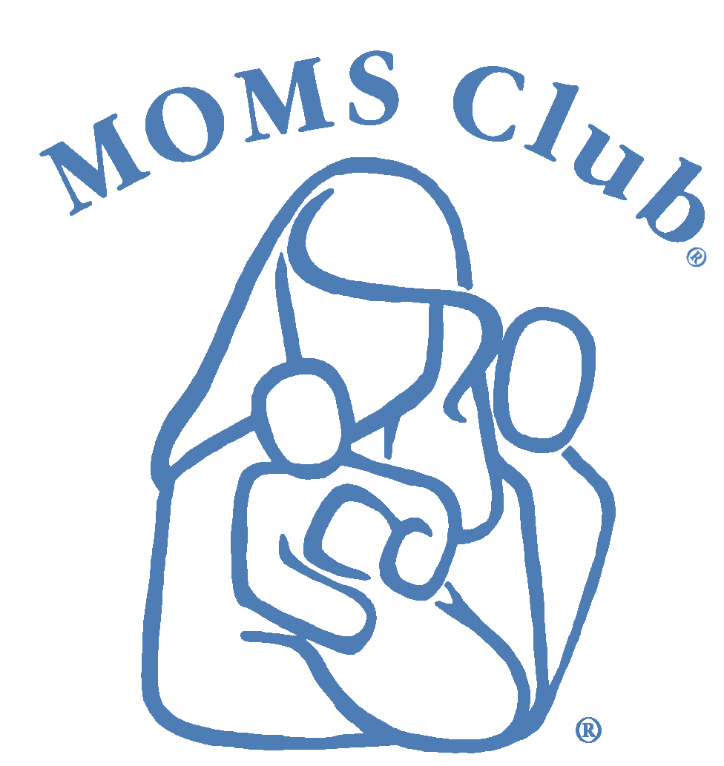
Membership Information & Liability Form

MOMS Club® of CHAPTER NAME, STATE

General Information
Name
Street Address
City, State, Zip
Home Phone
Cell Phone
E-Mail Address
Birthday
Spouse/Partner’s Name

Children’s Information (If you have more children, please continue on back)
Name |  | Birthday
Name |  | Birthday
Name |  | Birthday
Name |  | Birthday

About You
Have you ever been a member of this or any other local MOMS Club®?
If so, which chapter and when?
How did you hear about us?

Agreement and Signature
I, THE UNDERSIGNED, UNDERSTAND THAT MY PARTICIPATION AND THE PARTICIPATION OF ANY MEMBERS OF MY FAMILY IN ANY MOMS CLUB ACTIVITY OR PROGRAM IS COMPLETELY VOLUNTARY, AND WE HEREBY GIVE PERMISSION FOR MYSELF AND MY FAMILY TO JOIN IN THOSE ACTIVITIES OR PROGRAMS. MY FAMILY SHALL HOLD HARMLESS THIS LOCAL MOMS CLUB, THE MOMS CLUB CORPORATION, ANY MOMS CLUB VOLUNTEERS OR REPRESENTATIVES, PAID OR UNPAID, AND/OR THE PROVIDERS OF ANY ACTIVITY OR PROGRAM LOCATION AND/OR MATERIALS FROM ANY LIABILITY AND/OR RESPONSIBILITY FOR ANY ACCIDENT, ILLNESS OR INJURY THAT OCCURS DURING OR AS A RESULT OF ANY FUNCTION OR PROGRAM. I ACCEPT THAT THE FINAL RESPONSIBILITY FOR MY SAFETY AND THAT OF MY FAMILY RESTS WITH ME.
Signature
Date

